

Corporate Style Guide

December 28, 2016

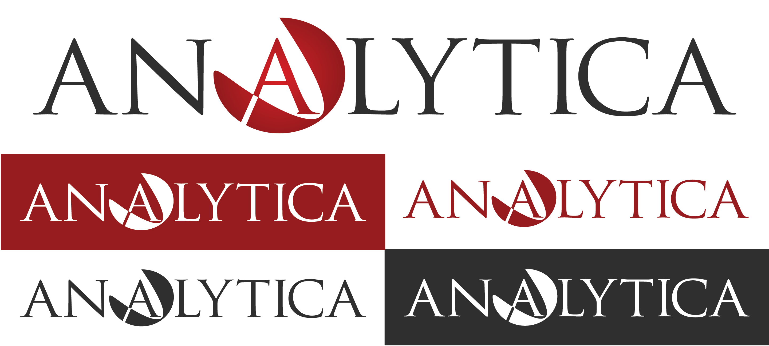Our Logo

Official Logo

The official full logo featuring the wordmark with the second ‘A’ replaced by the icon. This should be used whenever possible to represent the company. The options for use are:

* *Full color on white*
* *White on color (dark)*
* *Single color on white*
* *Black on white*
* *White on black*

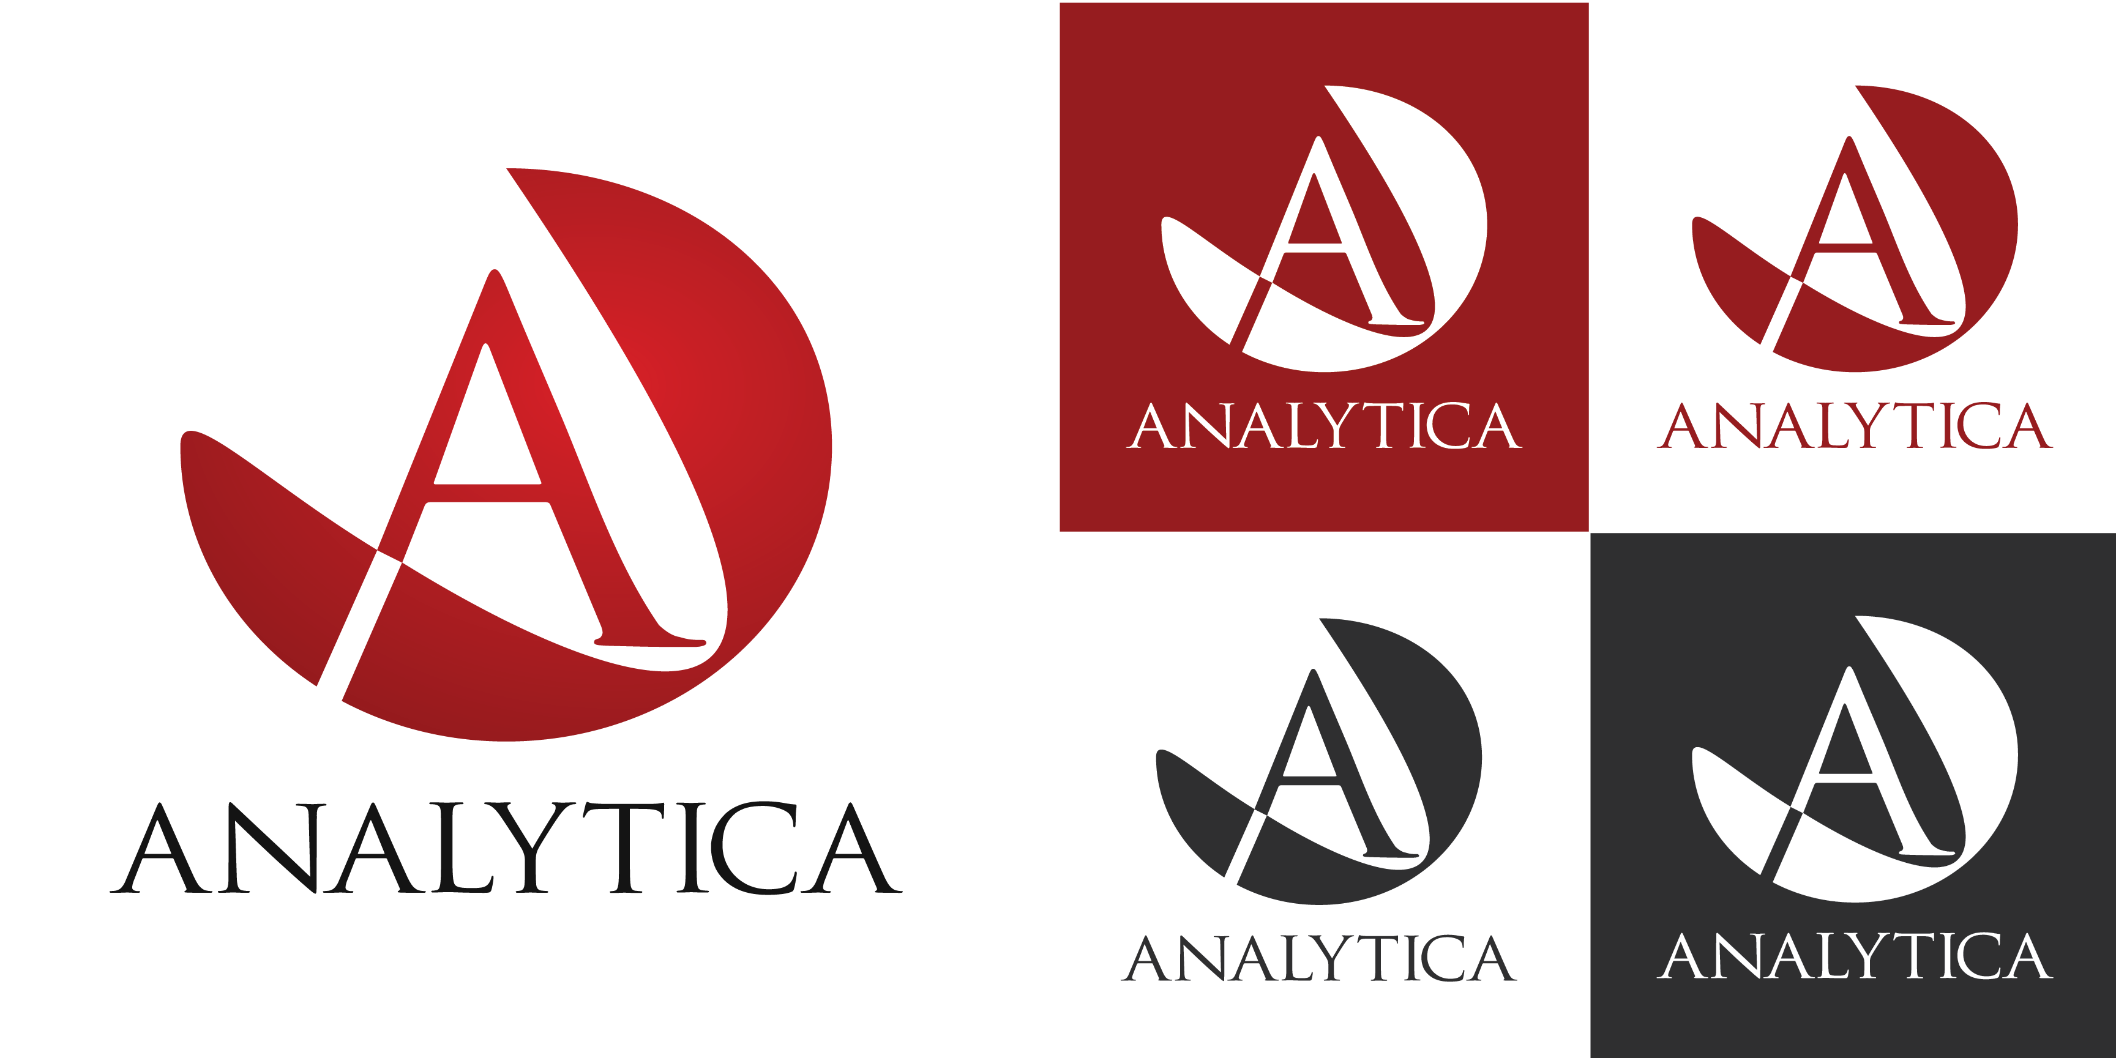

Alternate Logo

Alternate stacked version of the logo. This should be used when horizontal space is limited or when the design looks better with a ‘square’ logo. The options for use are:

* *Full color on white*
* *White on color (dark)*
* *Single color on white*
* *Black on white*
* *White on black*

Icon

The Icon only. Should be used when the size available does not allow for the company name to be clearly read in the first two versions of the logo. The options for use are:

* *Full color on white*
* *White on color (dark)*
* *Single color on white*
* *Black on white*
* *White on black*

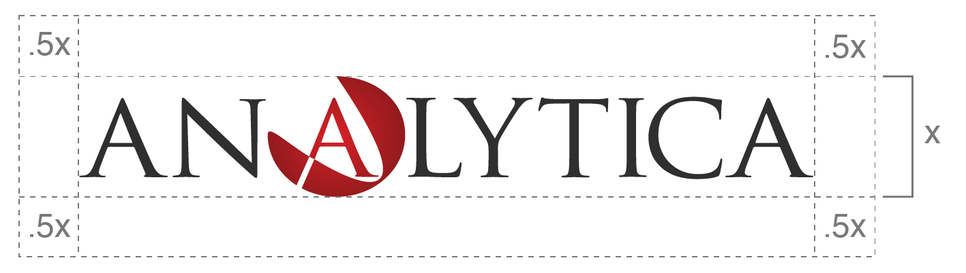Logo Specifications

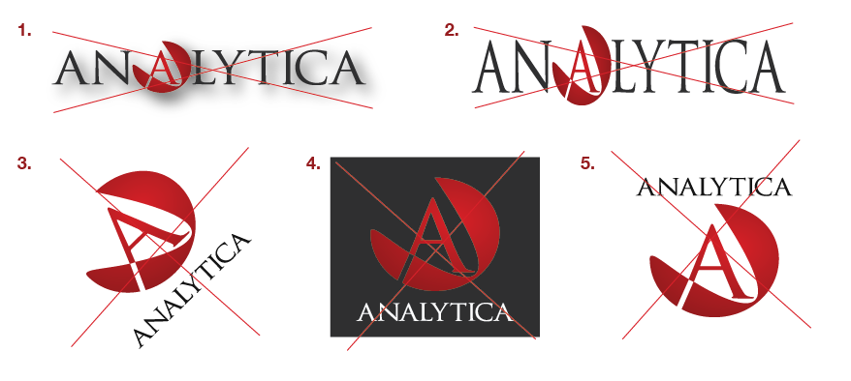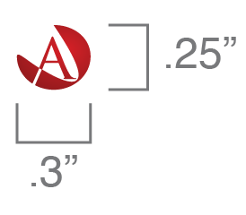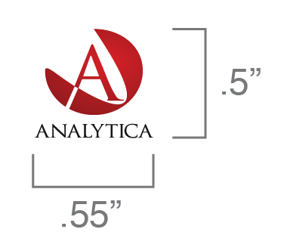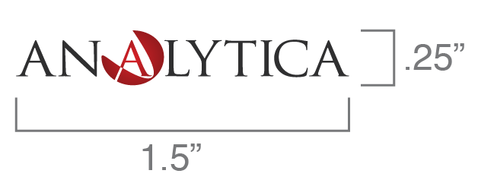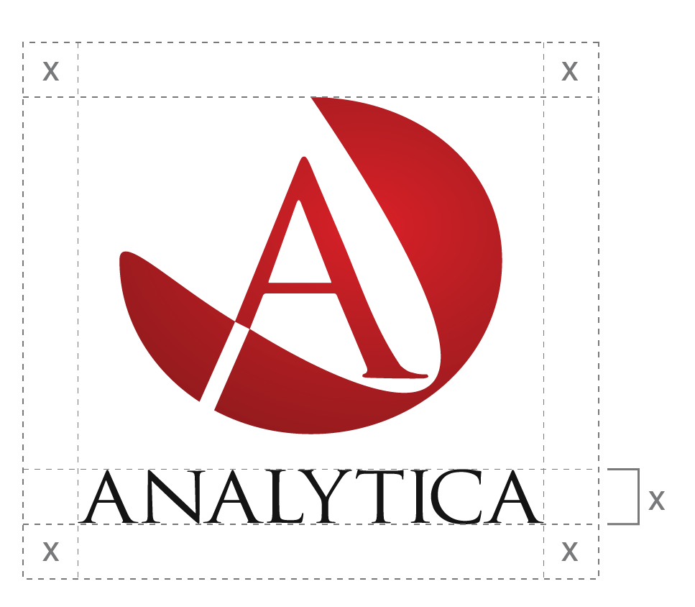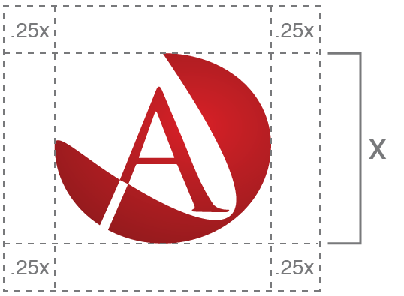

Don’ts

1. Apply effects
2. Distort the dimensions
3. Rotate
4. Use non specified color combination
5. Change the configuration

Minimum Size

All forms of the Analytica logo must of the minimum size for clear legibility.

Clear Space

All forms of the Analytica logo must have a designated amount of clear space on each side. This is to ensure the logo is clearly visible and unobstructed by other elements.

Colors

Secondary Brand Palettes

These colors complement our primary brand palette and work well as accent colors and highlights to bring more range to the Analytica brand. This Palette should only be used to support the primary brand colors. For publications that are more complicated or have deeper levels of information, these accent colors can help communicate content more clearly.

CMYK: 26, 100, 98, 25

RGB: 150, 28, 31

HEX: #961C1F

CMYK: 9, 100, 98, 1

RGB: 215, 31, 40

HEX: #D71F28

CMYK: 0, 0, 0, 92

RGB: 21, 21, 21

HEX: #151515

CMYK: 0, 0, 0, 65

RGB: 90, 90, 90

HEX: #5A5A5A

CMYK: 7, 5, 5, 0

RGB: 235, 235, 235

HEX: #EBEBEB

Primary Brand Palette

These colors are to be used with the Analytica logo and in all places the Analytica brand is being communicated.

Bright

CMYK: 51, 80, 0, 0

RGB: 140, 81, 167

HEX: #8C51A7

CMYK: 0, 45, 79, 0

RGB: 255, 159, 72

HEX: #FF9F48

CMYK: 1, 10, 83, 0

RGB: 255, 221, 72

HEX: #ECCD06

RGB: 16, 175, 145

CMYK: 77, 4, 56, 0

HEX: #10AF91

CMYK: 71, 27, 0, 0

RGB: 15, 158, 238

HEX: #0F9EEE

CMYK: 100, 75, 38, 26

RGB: 6, 65, 98

HEX: #064162

CMYK: 89, 38, 70, 27

RGB: 9, 99, 82

HEX: #096352

CMYK: 37, 41, 100, 10

RGB: 158, 131, 14

HEX: #9E830E

CMYK: 16, 73, 100, 5

RGB: 201, 95, 0

HEX: #C95F00

CMYK: 80, 98, 33, 26

RGB: 73, 35, 91

HEX: #49235B

Dark

Colors (Continued)

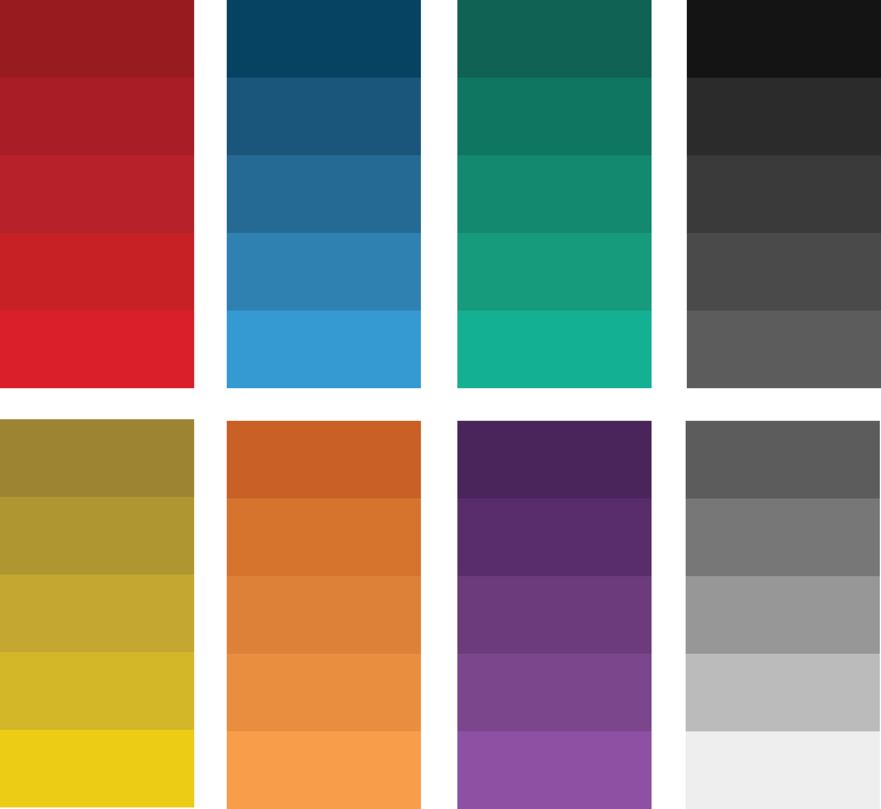

Color Gradients

These gradient hues fill the gap between the dark and bright colors in the Palette. These colors are to be used when a gradient or variation on a single color is needed for Aalytica’s brand identity.

Typography

Our primary typeface for all body text is Helvetica Neue. We utilize regular weight for standard copy and can use other weights and styles to give emphasis. Our heading typeface is Century Gothic in regular weight. All font choices should follow the standards outlined below.

